# Exam communication systems 2024

Exam ID: Au689481

Indholdsfortegnelse

Exam communication systems 2024 1

Problem 1 - Bipolar NRZ 1

a. 1

Problem 2 - Symbols with probability 3

b. Calculate the entropy 3

c. Construct a huffman code for this source and calculate the average codeword length. 3

d. Let the source be extended to order two by grouping two symbols and encoding altogether. Fill out the following probability distribution first, apply the Huffman algorithm, and calculate the average codeword length. [12 Points] 4

5

e. Now we let the source be extended to order n by grouping n symbols and encoding altogether. What will be the average codeword length asn→∞? [5Points] 9

Problem 3 - Nonlinear modulation 10

a. Calculate the Fourier Transform S(f) of s(t) for general values of a, b, K, fc 10

b. Please write the expected modulated signal when using DSB-SC 11

c. For the non-linear system in (a), show the appropriate choice of K in terms of a, b that produces a DSB-SC modulation without filtering. (8 points) 12

d. For the non-linear system in (a), draw a block diagram of the modulation system (8 points) 12

## Problem 1 - Bipolar NRZ

### 

I could have look into this equation and maybe used that to find the answer.

## Problem 2 - Symbols with probability

### Calculate the entropy

The entropy of a source can be written as

$$\sum_{i=1}^{k}{p_{i}·\log_{2}\left(\frac{1}{p_{i}}\right)}$$

Where *k* is the amounts of symbols sent.

$$p_{1}=0,3$$

$$p_{2}=0,3$$

$$p_{3}=0,2$$

$$p_{4}=0,2$$

The entropy of our source is then.

$$H\left(S\right)=0,3·\log_{2}\left(\frac{1}{0,3}\right)+0,3·\log_{2}\left(\frac{1}{0,3}\right)+0,2·\log_{2}\left(\frac{1}{0,2}\right)+0,2·\log_{2}\left(\frac{1}{0,2}\right)$$

==============

$H\left(S\right)≈1,97095$

==============

Which is a measure of average information pr. Symbol

### Construct a huffman code for this source and calculate the average codeword length.

For this I will do the huffman tree to find the sources codeword.

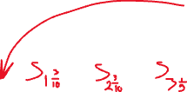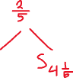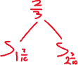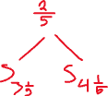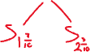

================================================================================

|  |  |  |
| --- | --- | --- |
| Symbol | Probability | Codeword |
| $$s_{1}$$ | $$\frac{3}{10}$$ | 00 |
| $$s_{2}$$ | $$\frac{3}{10}$$ | 01 |
| $$s_{3}$$ | $$\frac{2}{10}$$ | 10 |
| $$s_{4}$$ | $$\frac{2}{10}$$ | 11 |

Average length of codewords is

$$len=\frac{2·4}{4}=2$$

================================================================================

### Let the source be extended to order two by grouping two symbols and encoding altogether. Fill out the following probability distribution first, apply the Huffman algorithm, and calculate the average codeword length. [12 Points]

This makes of 4*4 = 16 new symbols

$$p_{1}=0,3$$

$$p_{2}=0,3$$

$$p_{3}=0,2$$

$$p_{4}=0,2$$

Let me also denote these as character in alphabetic order

$$ABCDE…$$

|  |  |  |  |  |  |  |  |  |
| --- | --- | --- | --- | --- | --- | --- | --- | --- |
| s | $$s_{1}s_{1}$$ | $$s_{1}s_{2}$$ | $$s_{1}s_{3}$$ | $$s_{1}s_{4}$$ | $$s_{2}s_{1}$$ | $$s_{2}s_{2}$$ | $$s_{2}s_{3}$$ | $$s_{2}s_{4}$$ |
| New-s | A | B | C | D | E | F | G | H |
| $P\left(s\right)$ | $$0,09$$ | $$0,09$$ | $$0,06$$ | $$0,06$$ | $$0,09$$ | $$0,09$$ | $$0,06$$ | $$0,06$$ |
|  |  |  |  |  |  |  |  |  |
| s | $$s_{3}s_{1}$$ | $$s_{3}s_{2}$$ | $$s_{3}s_{3}$$ | $$s_{3}s_{4}$$ | $$s_{4}s_{1}$$ | $$s_{4}s_{2}$$ | $$s_{4}s_{3}$$ | $$s_{4}s_{4}$$ |
| New-s | I | J | K | L | M | N | O | P |
| $P\left(s\right)$ | $$0,06$$ | $$0,06$$ | $$0,04$$ | $$0,04$$ | $$0,06$$ | $$0,06$$ | $$0,04$$ | $$0,04$$ |

So I’ve got 4 symbols with a smaller probability than 0.06, these will be my first branches.

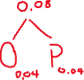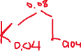

### 

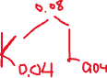

Now I’ve got 8 symbols of 0.06 which are of lowest probability. Each sum of these probabilities will go to the front.

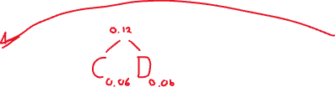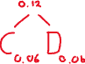

Now the least probable combination is $KL or OP$. Their probability together will go to the front.

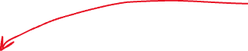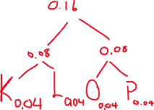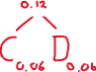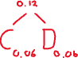

Now I’ve got 4 symbols with a probability of 0,09 being the least probable symbols to get at this stage. Bringing two of these together equals a probability of 0,18, which will go to the front.

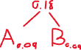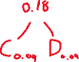

Now the least significant combinations are the 4 0.12 probabilities. CD, GH, IJ, MN. They sum up to 0.24, and becomes the most probable combinations at this stage

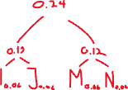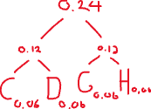

Now I’ve got one 0.16, 2*0.18, 2*0,24 left. The 0.16 and one 0.18 are the least common ones at this stage. Together they add to 0.34. They becomes the most common ones in the next stage.

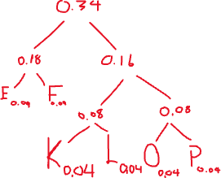

So now is left, 0.34, 2*0.24, and 0.18. One 0.18 and one 0.24

Is the least common ones at this stage. They becomes the most

common combination at next stage.

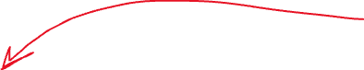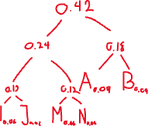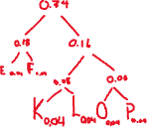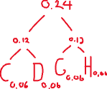

I’m now almost done. Combinations 0.42, 0.34, 0.24 left. The 0.24, 0.34 are the least common ones. They add to $0.58$. With now 2 combinations at next stage, I’m done.

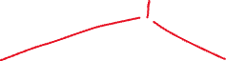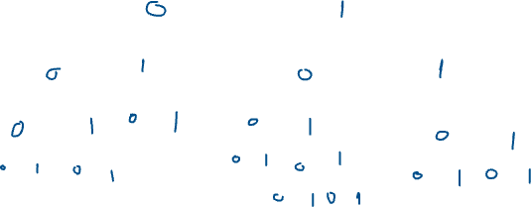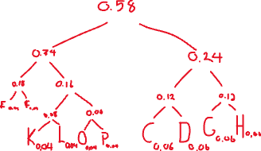

Now finding the codewords.

|  |  |  |  |  |  |  |  |  |
| --- | --- | --- | --- | --- | --- | --- | --- | --- |
| s | $$s_{1}s_{1}$$ | $$s_{1}s_{2}$$ | $$s_{1}s_{3}$$ | $$s_{1}s_{4}$$ | $$s_{2}s_{1}$$ | $$s_{2}s_{2}$$ | $$s_{2}s_{3}$$ | $$s_{2}s_{4}$$ |
| New-s | A | B | C | D | E | F | G | H |
| $P\left(s\right)$ | $$0,09$$ | $$0,09$$ | $$0,06$$ | $$0,06$$ | $$0,09$$ | $$0,09$$ | $$0,06$$ | $$0,06$$ |
| Codeword | 010 | 011 | 1100 | 1101 | 1000 | 1001 | 1110 | 1111 |
|  |  |  |  |  |  |  |  |  |
| s | $$s_{3}s_{1}$$ | $$s_{3}s_{2}$$ | $$s_{3}s_{3}$$ | $$s_{3}s_{4}$$ | $$s_{4}s_{1}$$ | $$s_{4}s_{2}$$ | $$s_{4}s_{3}$$ | $$s_{4}s_{4}$$ |
| New-s | I | J | K | L | M | N | O | P |
| $P\left(s\right)$ | $$0,06$$ | $$0,06$$ | $$0,04$$ | $$0,04$$ | $$0,06$$ | $$0,06$$ | $$0,04$$ | $$0,04$$ |
| Codeword | 0000 | 0001 | 10100 | 10101 | 0010 | 0011 | 10110 | 10111 |

Which looks right. The huffman coding is made, so that the least common symbol sources, get the longest codeword.

I’ve got 2 codewords of length 3, 8 of codeword length 4 with probability 0,06 and 2 of codeword length 4 with probability of 0,09. 4 codewords of length 5 with probability of 0,04.

Then I do a product of the amount times the length times its probability, to calculate the average codelength.

$2·3·0,09+8·4·0,06+2·4·0,09+4·5·0,04≈3,98$

============================

$len_{average}≈3,98$

============================

So for the 16 symbol sources, the average length of the codewords are 3.98.

Which is half of what it would have taken to represent each symbol source in ASCII 8 bits.

### Now we let the source be extended to order n by grouping n symbols and encoding altogether. What will be the average codeword length asn→∞? [5Points]

The general formula will be

$$ACL=\sum_{i=1}^{n}{p_{i}·length\left(H_{i}\right)}$$

## Problem 3 - Nonlinear modulation

The resulting signal output is

$$s\left(t\right)=a·K^{2}·{\left(x\left(t\right)+A·\cos\left(2πf_{c}t\right)\right)}^{2}-b·{\left(x\left(t\right)-A·\cos\left(2πf_{c}t\right)\right)}^{2}$$

Where the input signal is $x\left(t\right)$

### Calculate the Fourier Transform S(f) of s(t) for general values of a, b, K, fc

Let me start by expanding the resulting signal.

$$s\left(t\right)=a·K^{2}·{\left(x\left(t\right)+A·\cos\left(2πf_{c}t\right)\right)}^{2}-b·{\left(x\left(t\right)-A·\cos\left(2πf_{c}t\right)\right)}^{2}$$

$${\left(x\left(t\right)+A·\cos\left(2πf_{c}t\right)\right)}^{2}=x{\left(t\right)}^{2}+A^{2}\cos^{2}\left(2π f_{c}·t\right)+2 x\left(t\right)·A·\cos\left(2π f_{c}·t\right)$$

$$s\left(t\right)=a·K^{2}{\left(x\left(t\right)+A·\cos\left(2πf_{c}t\right)\right)}^{2}$$

$$+…$$

$$s\left(t\right)=a·K^{2}x{\left(t\right)}^{2}+a·K^{2}·A^{2}·\cos^{2}\left(2π f_{c}·t\right)+a·K^{2}·2 x\left(t\right)·A·\cos\left(2π f_{c}·t\right)$$

$$+…$$

The next square equation just has its last part switched sign.

$$s\left(t\right)=a·K^{2}x{\left(t\right)}^{2}+a·K^{2}·A^{2}·\cos^{2}\left(2π f_{c}·t\right)+a·K^{2}·2 x\left(t\right)·A·\cos\left(2π f_{c}·t\right)$$

$$+ bx{\left(t\right)}^{2}+bA^{2}\cos^{2}\left(2π f_{c}·t\right)-2b x\left(t\right)·A·\cos\left(2π f_{c}·t\right)$$

Factorizing for the constants.

$$s\left(t\right)=x{\left(t\right)}^{2}\left(a·K^{2}+b\right)$$

$$+\cos^{2}\left(2π f_{c}·t\right)·\left(a·K^{2}·A^{2}+bA^{2}\right)+$$

$$+x\left(t\right)\cos\left(2π f_{c}·t\right)·\left(2a·K^{2}A-2bA\right)$$

And now I want to get a different expression than cos^2.

Using the trigonometric identity for cos^2:

$$s\left(t\right)=x{\left(t\right)}^{2}\left(a·K^{2}+b\right)$$

$$+(\frac{1+\cos\left(4π f_{c}·t\right)}{2}·\left(a·K^{2}·A^{2}+bA^{2}\right)$$

$$+x\left(t\right)\cos\left(2π f_{c}·t\right)·\left(2a·K^{2}A-2bA\right)$$

$$s\left(t\right)=x{\left(t\right)}^{2}\left(a·K^{2}+b\right)$$

$$+\frac{K^{2}·A^{2}+bA^{2}}{2}$$

$$+\cos\left(4π f_{c}·t\right)·\frac{\left(K^{2}·A^{2}+bA^{2}\right)}{2}$$

$$+x\left(t\right)\cos\left(2π f_{c}·t\right)·\left(2a·K^{2}A-2bA\right)$$

Generally for the product of two functions in the time domain equals convolution in the frequency domain.

$$x\left(t\right)·x\left(t\right)→^{F}X\left(f\right)⋆X\left(f\right)$$

I have two products of functions for t and one function of cos.

As the system was nonlinear, I am not sure, if lineary principle holds for constant. Technically the constants aren’t within the nonlinear functions, but just a constant to it’s results, so it might be fine. I’m skeptical, but I have no better plan, so I make the assumption, that the linear principle still holds.

For the constant function, this will just be the constant times a pulse.

### Please write the expected modulated signal when using DSB-SC

For a DSB-SC modulation, only the upper and lower sidebands consists.

I don’t know at what frequency the containing of X uses. But if I assume it to be of lower frequency than 2 times the carrier frequency, the resultant signal when using DSB-SC would be.

$$S_{2}\left(f\right)=\frac{K^{2}·A^{2}+bA^{2}}{4}[δ\left(f-2f_{c}\right)+δ\left(f+2f_{c}\right)$$

$$S_{2}\left(t\right)=\frac{K^{2}·A^{2}+bA^{2}}{4}·\cos\left(2π·2f_{c}t\right)$$

### For the non-linear system in (a), show the appropriate choice of K in terms of a, b that produces a DSB-SC modulation without filtering. (8 points)

$$S\left(f\right)=\left(a·K^{2}+b\right)·X\left(f\right)⋆\left(a·K^{2}+b\right)X\left(f\right)$$

$$+\frac{K^{2}·A^{2}+bA^{2}}{2}·δ\left[f\right]$$

$$+\frac{K^{2}·A^{2}+bA^{2}}{4}[δ\left(f-2f_{c}\right)+δ\left(f+2f_{c}\right)$$

$$+\left(2a·K^{2}A-2bA\right)X\left(f\right)⋆\left(\left(a·K^{2}A-bA\right)·\left[δ\left(f-f_{c}\right)+δ\left(f+f_{c}\right)\right]\right)$$

$$a·K^{2}·A-2bA=0$$

Would make one of the frequencies go away.

$$K^{2}=\frac{2bA}{aA}=\frac{2b}{a}$$

$$K=±\sqrt{\frac{2b}{a}}$$

It doesn’t make the other frequencies go away though.

Resulting frequencies:

$$S\left(f\right)=\left(a·K^{2}+b\right)·X\left(f\right)⋆\left(a·K^{2}+b\right)X\left(f\right)$$

$$+\frac{K^{2}·A^{2}+bA^{2}}{2}·δ\left[f\right]$$

$$+\frac{K^{2}·A^{2}+bA^{2}}{4}[δ\left(f-2f_{c}\right)+δ\left(f+2f_{c}\right)$$

$$K=±\sqrt{\frac{2b}{a}}$$

### For the non-linear system in (a), draw a block diagram of the modulation system (8 points)

